
Late Bhausaheb Hiray S.S. Trust’s Institute of Computer Application
CERTIFICATE
This is to certify that Pratham Salunkhe of MCA Semester - I with Roll No. MCA2024107 has completed all practical’s of MCAL 11 Advanced Data Structure Lab under the guidance of Sheetal Waghmare, in this college during the year 2024-2025.
CO | Attendance | Performanc e during  Lab session | Innovatio n in  problem solving techniques | Mock  Viva during  Lab  session | Journal
CO1
CO2
CO3
CO4
CO5
Subject In-Charge Director
Examiner

Index
Sr.  No. | Title | CO | Date | Sign
1. | Implementation of different sorting techniques | CO1 | 9/10/2024
 | a) To implement bubble sort
 | b) To implement insertion sort
 | c) To implement selection sort
 | d) To implement shell sort
 | e) To implement radix sort
 | f) To implement quick sort
2. | Implementation of different searching techniques | CO1 | 9/10/2024
 | a) To implement linear search
 | b) To implement binary search
3. | Implementation of Stacks (Using Arrays) | CO2 | 16/10/2024
 | a) To implement Stack using array
 | b) To implement Stack using linked list
4. | Implementation of Stack Application | CO2 | 18/10/2024
 | a) To implement Postfix evaluation
 | b) To implement Balancing of Parenthesis
5. | Implement all different types of queues | CO2 | 23/10/2024
 | a) To implement Circular Queue
6. | Demonstrate application of queue | CO2 | 25/10/2024
 | a) To implement Priority Queue
7. | Implementation of all types of linked list | CO2 | 06/11/2024
 | a) To implement Single Linked List
 | b) To implement Double Linked list
 | c) To implement Circular Linked List

8. | Demonstrate application of linked list | CO2 | 08/11/2024
 | a) To implement Polynomial Addition
 | b) To implement Sparse Matrix
9. | Create and perform various operations on BST | CO3 | 15/11/2024
 | a) Inserting node in BST
 | b) Deleting the node from BST
 | c) To find height of Tree
 | d) To perform Inorder
 | e) To perform Preorder
 | f) To perform Postorder
 | g) To find Maximum value of tree
10. | Implementing Heap with different operations performed | CO3 | 22/11/2024
 | a) To perform insertion operation
 | b) To create Heap using Heapify method
 | c) To perform Heap sort
 | d) To delete the value in heap
11. | Create a graph storage structure | CO3 | 27/11/2024
 | a) Adjacency Matrix
12. | Perform various hashing techniques with Linear Probe as collision resolution scheme. | CO4 | 29/11/2024
13. | Create a minimum spanning tree using any method Kruskal’s algorithm or Prim’s algorithm | CO3 | 04/12/2024
14. | Implementation of Graph Traversal | CO3 | 13/12/2024
 | a) Implement Depth First Search (DFS)
 | b) Implement Breath First Search (BFS)

Practical 1:
Bubble Sort Algorithm:
Java Program: Buble Sort with Step-by-Step Output:
import java.util.Scanner;
public class BubbleSortSteps {
public static void main(String[] args) {
Scanner scanner = new Scanner(System.in);
// Input the size of the array
System.out.print("Enter the number of elements: ");
int n = scanner.nextInt();
// Input array elements
int[] arr = new int[n];
System.out.println("Enter " + n + " elements:");
for (int i = 0; i < n; i++) {
arr[i] = scanner.nextInt();
}
System.out.println("Original array:");
printArray(arr);
// Perform Bubble Sort with steps
bubbleSortWithSteps(arr);
System.out.println("Sorted array:");
printArray(arr);
scanner.close();
}
// Bubble sort with step-by-step output
public static void bubbleSortWithSteps(int[] arr) {
int n = arr.length;
boolean swapped;
for (int i = 0; i < n - 1; i++) {
swapped = false;
System.out.println("\nPass " + (i + 1) + ":");
for (int j = 0; j < n - 1 - i; j++) {
if (arr[j] > arr[j + 1]) {
// Swap arr[j] and arr[j + 1]
int temp = arr[j];
arr[j] = arr[j + 1];
arr[j + 1] = temp;
swapped = true;
}
// Print array after each comparison
printArray(arr);
}
// If no swaps occurred, array is sorted
if (!swapped) {
System.out.println("No swaps needed. Array is sorted.");
break;
}
}
}
// Utility method to print the array
public static void printArray(int[] arr) {
for (int num : arr) {
System.out.print(num + " ");
}
System.out.println();
}}

Example Input and Output:
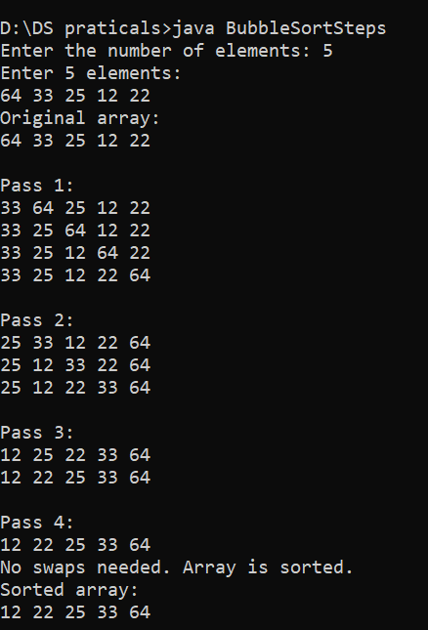

Selection Sort Algorithm:
Java Program: Selection Sort with Step-by-Step Output:
import java.util.Scanner;
public class SelectionSortSteps {
public static void main(String[] args) {
Scanner scanner = new Scanner(System.in);
// Input the size of the array
System.out.print("Enter the number of elements: ");
int n = scanner.nextInt();
// Input array elements
int[] arr = new int[n];
System.out.println("Enter " + n + " elements:");
for (int i = 0; i < n; i++) {
arr[i] = scanner.nextInt();
}
System.out.println("Original array:");
printArray(arr);
// Perform Selection Sort with steps
selectionSortWithSteps(arr);
System.out.println("Sorted array:");
printArray(arr);
scanner.close();
}
// Selection sort with step-by-step output
public static void selectionSortWithSteps(int[] arr) {
int n = arr.length;
for (int i = 0; i < n - 1; i++) {
int minIndex = i; // Index of the smallest element
for (int j = i + 1; j < n; j++) {
if (arr[j] < arr[minIndex]) {
minIndex = j;
}
}
// Swap the smallest element with the first element of the unsorted portion
int temp = arr[minIndex];
arr[minIndex] = arr[i];
arr[i] = temp;
// Print the array after each pass
System.out.println("\nAfter pass " + (i + 1) + ":");
printArray(arr);
}
}
// Utility method to print the array
public static void printArray(int[] arr) {
for (int num : arr) {
System.out.print(num + " ");
}
System.out.println();
}
}
Example Input and Output:
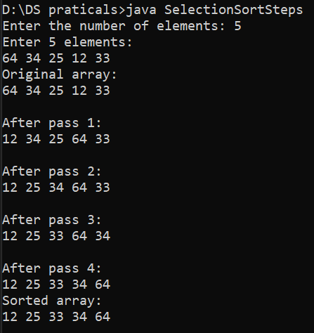

Insertion Sort Algorithm:
Java Program: Insertion Sort with Step-by-Step Output:
import java.util.Scanner;
public class InsertionSortSteps {
public static void main(String[] args) {
Scanner scanner = new Scanner(System.in);
// Input the size of the array
System.out.print("Enter the number of elements: ");
int n = scanner.nextInt();
// Input array elements
int[] arr = new int[n];
System.out.println("Enter " + n + " elements:");
for (int i = 0; i < n; i++) {
arr[i] = scanner.nextInt();
}
System.out.println("Original array:");
printArray(arr);
// Perform Insertion Sort with steps
insertionSortWithSteps(arr);
System.out.println("Sorted array:");
printArray(arr);
scanner.close();
}
// Insertion sort with step-by-step output
public static void insertionSortWithSteps(int[] arr) {
int n = arr.length;
for (int i = 1; i < n; i++) {
int key = arr[i]; // Current element to be inserted
int j = i - 1;
// Move elements of the sorted portion that are greater than key
while (j >= 0 && arr[j] > key) {
arr[j + 1] = arr[j];
j--;
}
// Insert the current element at the correct position
arr[j + 1] = key;
// Print the array after each insertion
System.out.println("\nAfter inserting element " + key + ":");
printArray(arr);
}
}
// Utility method to print the array
public static void printArray(int[] arr) {
for (int num : arr) {
System.out.print(num + " ");
}
System.out.println();
}
}
Example Input and Output:
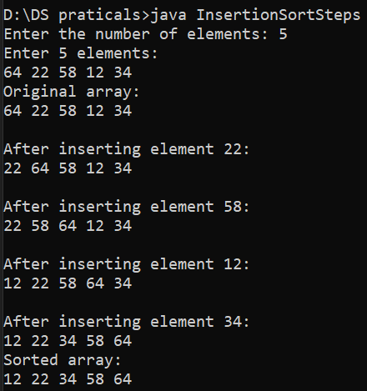

Shell Sort Algorithm:
Java Program: Shell Sort with Step-by-Step Output:
import java.util.Scanner;
public class ShellSortSteps {
public static void main(String[] args) {
Scanner scanner = new Scanner(System.in);
// Input the size of the array
System.out.print("Enter the number of elements: ");
int n = scanner.nextInt();
// Input array elements
int[] arr = new int[n];
System.out.println("Enter " + n + " elements:");
for (int i = 0; i < n; i++) {
arr[i] = scanner.nextInt();
}
System.out.println("Original array:");
printArray(arr);
// Perform Shell Sort with steps
shellSortWithSteps(arr);
System.out.println("Sorted array:");
printArray(arr);
scanner.close();
}
// Shell Sort with step-by-step output
public static void shellSortWithSteps(int[] arr) {
int n = arr.length;
// Start with a large gap, then reduce the gap
for (int gap = n / 2; gap > 0; gap /= 2) {
System.out.println("\nGap = " + gap + ":");
// Perform a gapped insertion sort
for (int i = gap; i < n; i++) {
int temp = arr[i];
int j;
// Shift earlier gap-sorted elements up until the correct location is found
for (j = i; j >= gap && arr[j - gap] > temp; j -= gap) {
arr[j] = arr[j - gap];
}
// Put temp (the original arr[i]) in its correct location
arr[j] = temp;
// Print the array after each insertion
printArray(arr);
}
}
}
// Utility method to print the array
public static void printArray(int[] arr) {
for (int num : arr) {
System.out.print(num + " ");
}
System.out.println();
}
}
Example Input and Output:
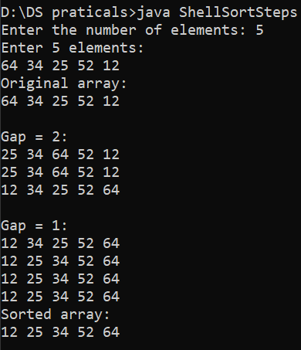
Radix Sort in Detail
Java Program: Shell Sort with Step-by-Step Output:
import java.util.Arrays;
public class RadixSort {
// Main function to implement Radix Sort
public static void radixSort(int[] arr) {
// Find the maximum number to determine the number of digits
int max = Arrays.stream(arr).max().getAsInt();
// Apply counting sort for each digit
for (int exp = 1; max / exp > 0; exp *= 10) { // Corrected exp update
countingSort(arr, exp);
}
}
// Counting sort used as a subroutine
private static void countingSort(int[] arr, int exp) {
int n = arr.length;
int[] output = new int[n]; // Output array to store sorted numbers
int[] count = new int[10]; // Count array for digits 0-9
// Count the occurrences of each digit at the current position
for (int i = 0; i < n; i++) {
int digit = (arr[i] / exp) % 10;
count[digit]++;
}
// Update count[i] to store the actual position of this digit in output
for (int i = 1; i < 10; i++) {
count[i] += count[i - 1];
}
// Build the output array by placing numbers in sorted order of the current digit
for (int i = n - 1; i >= 0; i--) {
int digit = (arr[i] / exp) % 10;
output[count[digit] - 1] = arr[i];
count[digit]--;
}
// Copy the sorted numbers back to the original array
System.arraycopy(output, 0, arr, 0, n);
}
// Driver function to test the algorithm
public static void main(String[] args) {
int[] arr = { 170, 45, 75, 90, 802, 24, 2, 66 };
System.out.println("Original Array: " + Arrays.toString(arr));
radixSort(arr);
System.out.println("Sorted Array: " + Arrays.toString(arr));
}
}
Example Input and Output:
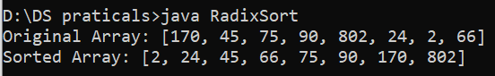

Quick Sort in Detail
Java Program: Quick Sort with Step-by-Step Output:
import java.util.Arrays;
public class QuickSort {
// Function to perform Quick Sort
public static void quickSort(int[] arr, int low, int high) {
if (low < high) {
// Partition the array and get the pivot index
int pi = partition(arr, low, high);

// Recursively sort elements before and after the pivot
quickSort(arr, low, pi - 1);
quickSort(arr, pi + 1, high);
}
}
// Partition function
private static int partition(int[] arr, int low, int high) {
int pivot = arr[high]; // Pivot element
int i = low - 1; // Index of smaller element
for (int j = low; j < high; j++) {
// If the current element is smaller than the pivot
if (arr[j] < pivot) {
i++;
// Swap arr[i] and arr[j]
int temp = arr[i];
arr[i] = arr[j];
arr[j] = temp;
}
}
// Swap arr[i+1] and arr[high] (the pivot)
int temp = arr[i + 1];
arr[i + 1] = arr[high];
arr[high] = temp;

return i + 1; // Return the pivot index
}
// Main method to test the Quick Sort
public static void main(String[] args) {
int[] arr = {10, 80, 30, 90, 40, 50, 70};
System.out.println("Original Array: " + Arrays.toString(arr));
quickSort(arr, 0, arr.length - 1);
System.out.println("Sorted Array: " + Arrays.toString(arr));
}
}
Example Input and Output:
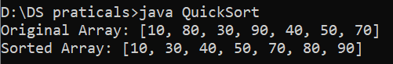

Practical 2:
Linear Search and Binary Search:
Linear Search
Java Program: Linear Search with Step-by-Step Output:
public class LinearSearch {
// Function to perform Linear Search
public static int linearSearch(int[] arr, int target) {
for (int i = 0; i < arr.length; i++) {
if (arr[i] == target) {
return i; // Return the index if found
}
}
return -1; // Return -1 if not found
}
public static void main(String[] args) {
int[] arr = {10, 20, 30, 40, 50};
int target = 30;
int result = linearSearch(arr, target);
if (result != -1) {
System.out.println("Element found at index: " + result);
} else {
System.out.println("Element not found.");
}
}
}
Example Input and Output:
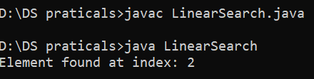

Binary Search Algorithm:
Java Program: Binary Search with Step-by-Step Output:
import java.util.Arrays;
public class BinarySearch {
// Function to perform Binary Search
public static int binarySearch(int[] arr, int target) {
int low = 0, high = arr.length - 1;
while (low <= high) {
int mid = low + (high - low) / 2;
if (arr[mid] == target) {
return mid; // Return the index if found
} else if (arr[mid] < target) {
low = mid + 1; // Search in the right subarray
} else {
high = mid - 1; // Search in the left subarray
}
}
return -1; // Return -1 if not found
}
public static void main(String[] args) {
int[] arr = {10, 20, 30, 40, 50};
int target = 30;
int result = binarySearch(arr, target);
if (result != -1) {
System.out.println("Element found at index: " + result);
} else {
System.out.println("Element not found.");
}
}
}

Example Input and Output:
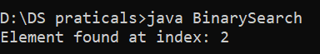

Practical 3:
Stack Data Structure
Implementing Stack Using Linked List in Java
import java.util.Scanner;
// Node class to represent each element in the linked list
class Node {
int data;
Node next;
// Constructor
Node(int data) {
this.data = data;
this.next = null;
}
}
// Stack class that implements stack operations using a linked list
class Stack {
private Node top;
private int size;
// Constructor
public Stack() {
this.top = null;
this.size = 0;
}
// Push operation
public void push(int data) {
Node newNode = new Node(data);
newNode.next = top; // Point new node to current top
top = newNode; // Make new node the top
size++;
System.out.println(data + " pushed to stack");
}
// Pop operation
public void pop() {
if (isEmpty()) {
System.out.println("Stack is empty. Nothing to pop.");
return;
}
int popped = top.data; // Remove top node
top = top.next;
size--;
System.out.println(popped + " popped from stack");
}
// Peek operation
public void peek() {
if (isEmpty()) {
System.out.println("Stack is empty. Nothing to peek.");
return;
}
System.out.println("Top element is: " + top.data);
}
// Check if stack is empty
public boolean isEmpty() {
return top == null;
}
// Get size of stack
public void getSize() {
System.out.println("Size of stack: " + size);
}
// Display all elements of the stack
public void display() {
if (isEmpty()) {
System.out.println("Stack is empty.");
return;
}
Node temp = top;
System.out.print("Stack elements: ");
while (temp != null) {
System.out.print(temp.data + " ");
temp = temp.next;
}
System.out.println();
}
}
public class StackUsingLinkedList {
public static void main(String[] args) {
Scanner scanner = new Scanner(System.in);
Stack stack = new Stack();
int choice;
// Menu-driven program
do {
System.out.println("\nStack Operations:");
System.out.println("1. Push");
System.out.println("2. Pop");
System.out.println("3. Peek");
System.out.println("4. Check if Stack is Empty");
System.out.println("5. Get Stack)
System.out.println("6. Display Stack");
System.out.println("7. Exit");
System.out.print("Enter your choice: ");
choice = scanner.nextInt();
switch (choice) {
case 1:
// Push operation
System.out.print("Enter element to push: ");
int data = scanner.nextInt();
stack.push(data);
break;
case 2:
// Pop operation
stack.pop();
break;
case 3:
// Peek operation
stack.peek();
break;
case 4:
// Check if stack is empty
if (stack.isEmpty()) {
System.out.println("Stack is empty.");
} else {
System.out.println("Stack is not empty.");
}
break;
case 5:
// Get size of stack
stack.getSize();
break;
case 6:
// Display stack
stack.display();
break;
case 7:
System.out.println("Exiting...");
break;
default:
System.out.println("Invalid choice. Please try again.");
}
} while (choice != 7);

scanner.close();
}
}

Example Input and Output:
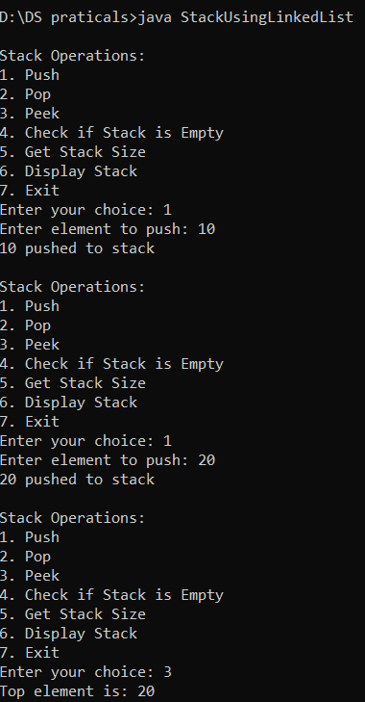
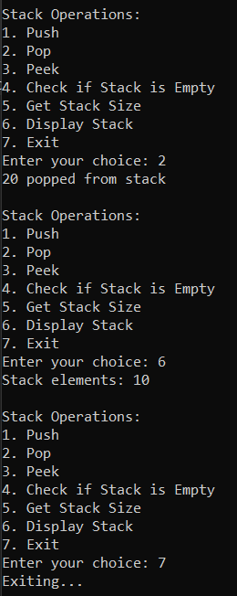
Stack Data Structure with Array Implementation
Java Program: Stack Using Array (Menu-Driven)
import java.util.Scanner;
// Stack class using an array
class Stack {
private int maxSize;
private int top;
private int[] stack;
// Constructor to initialize the stack with a maximum size
public Stack(int size) {
maxSize = size;
stack = new int[maxSize];
top = -1; // Stack is empty when top is -1
}
// Push operation
public void push(int data) {
if (top == maxSize - 1) {
System.out.println("Stack Overflow. Cannot push " + data);
} else {
stack[++top] = data;
System.out.println(data + " pushed to stack");
}
}
// Pop operation
public void pop() {
if (isEmpty()) {
System.out.println("Stack Underflow. Nothing to pop.");
} else {
int popped = stack[top--];
System.out.println(popped + " popped from stack");
}
}
// Peek operation
public void peek() {
if (isEmpty()) {
System.out.println("Stack is empty. Nothing to peek.");
} else {
System.out.println("Top element is: " + stack[top]);
}
}
// Check if stack is empty
public boolean isEmpty() {
return top == -1;
}
// Get the size of the stack
public void getSize() {
System.out.println("Size of stack: " + (top + 1));
}
// Display all elements of the stack
public void display() {
if (isEmpty()) {
System.out.println("Stack is empty.");
} else {
System.out.print("Stack elements: ");
for (int i = 0; i <= top; i++) {
System.out.print(stack[i] + " ");
}
System.out.println();
}
}
}
public class StackUsingArray {
public static void main(String[] args) {
Scanner scanner = new Scanner(System.in);
// Get the stack size from the user
System.out.print("Enter the maximum size of the stack: ");
int size = scanner.nextInt();
Stack stack = new Stack(size);
int choice;
// Menu-driven program
do {
System.out.println("\nStack Operations:");
System.out.println("1. Push");
System.out.println("2. Pop");
System.out.println("3. Peek");
System.out.println("4. Check if Stack is Empty");
System.out.println("5. Get Stack Size");
System.out.println("6. Display Stack");
System.out.println("7. Exit");
System.out.print("Enter your choice: ");
choice = scanner.nextInt();
switch (choice) {
case 1:
// Push operation
System.out.print("Enter element to push: ");
int data = scanner.nextInt();
stack.push(data);
break;
case 2:
// Pop operation
stack.pop();
break;
case 3:
// Peek operation
stack.peek();
break;
case 4:
// Check if stack is empty
if (stack.isEmpty()) {
System.out.println("Stack is empty.");
} else {
System.out.println("Stack is not empty.");
}
break;
case 5:
// Get size of stack
stack.getSize();
break;
case 6:
// Display stack
stack.display();
break;
case 7:
System.out.println("Exiting...");
break;
default:
System.out.println("Invalid choice. Please try again.");
}
} while (choice != 7);
scanner.close();
}
}

Example Input and Output:
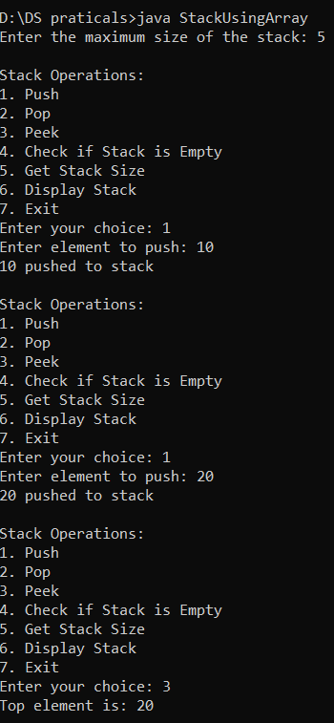
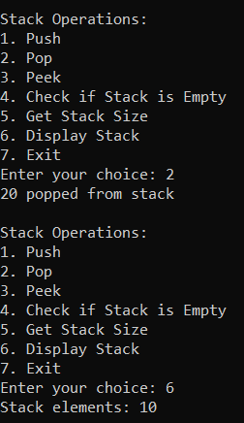

Practical 4:
Prefix, Infix, and Postfix Notation
Java Program: Postfix Expression Evaluation
import java.util.Scanner;
import java.util.Stack;
public class PostfixEvaluation {
// Method to evaluate a postfix expression
public static int evaluatePostfix(String expression) {
Stack<Integer> stack = new Stack<>();
// Traverse the expression
for (int i = 0; i < expression.length(); i++) {
char ch = expression.charAt(i);
// If the character is a digit, push it to the stack
if (Character.isDigit(ch)) {
stack.push(ch - '0'); // Convert character to integer
}
// If the character is an operator, pop two elements, apply the operator,
// and push the result
else {
int operand2 = stack.pop(); // Second operand
int operand1 = stack.pop(); // First operand
switch (ch) {
case '+':
stack.push(operand1 + operand2);
break;
case '-':
stack.push(operand1 - operand2);
break;
case '*':
stack.push(operand1 * operand2);
break;
case '/':
stack.push(operand1 / operand2);
break;
}
}
}
// The result is the only element left in the stack
return stack.pop();
}
public static void main(String[] args) {
Scanner scanner = new Scanner(System.in);
System.out.println("Enter a postfix expression (e.g., 235+): ");
String expression = scanner.nextLine();
int result = evaluatePostfix(expression);
System.out.println("The result of the postfix expression is: " + result);
scanner.close();
}
}

Example Input and Output:
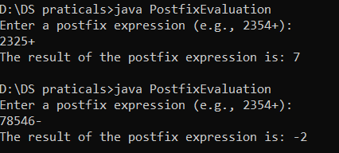

Balancing Parentheses Using a Stack
Java Program: ParenthesisBalancing
import java.util.Stack;
public class ParenthesisBalancing {
// Function to check if parentheses are balanced
public static boolean isBalanced(String expr) {
Stack<Character> stack = new Stack<>();
// Traverse the string
for (char ch : expr.toCharArray()) {
// Push open brackets onto the stack
if (ch == '(' || ch == '[' || ch == '{') {
stack.push(ch);
}
// Check for closing brackets
else if (ch == ')' || ch == ']' || ch == '}') {
// If stack is empty, it's unbalanced
if (stack.isEmpty()) {
return false;
}
// Pop the top element and check if it matches
char top = stack.pop();
if (!isMatchingPair(top, ch)) {
return false;
}
}
}
// If the stack is not empty, it's unbalanced
return stack.isEmpty();
}
// Helper function to check if two brackets are matching pairs
private static boolean isMatchingPair(char open, char close) {
return (open == '(' && close == ')') ||
(open == '[' && close == ']') ||
(open == '{' && close == '}');
}
// Main method to test the function
public static void main(String[] args) {
String expr = "{[()]}";
if (isBalanced(expr)) {
System.out.println("The expression is balanced.");
} else {
System.out.println("The expression is not balanced.");
}
}
}

Example Input and Output:
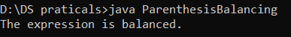

Practical 5:
Queue Data Structure
Java Implementation of Circular Queue with User Input:
import java.util.Scanner;
public class CircularQueueWithUserInput {
private int[] queue; // Array to store the queue elements
private int front; // Points to the front element
private int rear; // Points to the next insertion position
private int size; // Size of the queue
// Constructor to initialize the queue
public CircularQueueWithUserInput(int size) {
this.size = size;
this.queue = new int[size];
this.front = 0;
this.rear = 0;
}
// Check if the queue is full
public boolean isFull() {
return (rear + 1) % size == front;
}
// Check if the queue is empty
public boolean isEmpty() {
return front == rear;
}
// Add an element to the queue
public void enqueue(int element) {
if (isFull()) {
System.out.println("Queue is full. Cannot enqueue " + element);
return;
}
queue[rear] = element;
rear = (rear + 1) % size;
System.out.println("Enqueued: " + element);
}
// Remove and return the front element from the queue
public int dequeue() {
if (isEmpty()) {
System.out.println("Queue is empty. Cannot dequeue.");
return -1;
}
int element = queue[front];
front = (front + 1) % size;
System.out.println("Dequeued: " + element);
return element;
}
// Peek the front element without removing it
public int peek() {
if (isEmpty()) {
System.out.println("Queue is empty. Cannot peek.");
return -1;
}
return queue[front];
}
// Display the queue elements
public void display() {
if (isEmpty()) {
System.out.println("Queue is empty.");
return;
}
System.out.print("Queue: ");
int i = front;
while (i != rear) {
System.out.print(queue[i] + " ");
i = (i + 1) % size;
}
System.out.println();
}
// Main method to test the Circular Queue with user input
public static void main(String[] args) {
Scanner scanner = new Scanner(System.in);
System.out.print("Enter the size of the queue: ");
int size = scanner.nextInt();
CircularQueueWithUserInput cq = new CircularQueueWithUserInput(size + 1); // +1 to differentiate full vs empty
while (true) {
System.out.println("\nChoose an operation:");
System.out.println("1. Enqueue");
System.out.println("2. Dequeue");
System.out.println("3. Peek");
System.out.println("4. Display");
System.out.println("5. Exit");
System.out.print("Enter your choice: ");
int choice = scanner.nextInt();
switch (choice) {
case 1:
System.out.print("Enter the element to enqueue: ");
int element = scanner.nextInt();
cq.enqueue(element);
break;
case 2:
cq.dequeue();
break;
case 3:
int frontElement = cq.peek();
if (frontElement != -1) {
System.out.println("Front Element: " + frontElement);
}
break;
case 4:
cq.display();
break;
case 5:
System.out.println("Exiting...");
scanner.close();
return;
default:
System.out.println("Invalid choice. Please try again.");
}
}
}
}

Example Input and Output:
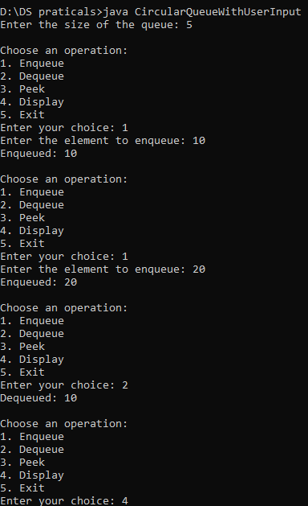
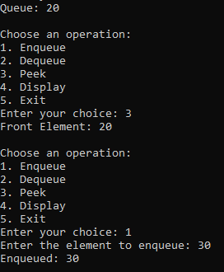
Practical 6:
Priority Queue
Java Implementation of Priority Queue with User Input:
import java.util.PriorityQueue;
import java.util.Scanner;
class Element implements Comparable<Element> {
int value;
int priority;
// Constructor
public Element(int value, int priority) {
this.value = value;
this.priority = priority;
}
// Compare elements based on priority (higher priority comes first)
@Override
public int compareTo(Element other) {
return Integer.compare(other.priority, this.priority); // Max-Heap style
}
@Override
public String toString() {
return "Value: " + value + ", Priority: " + priority;
}
}
public class UserInputPriorityQueue {
public static void main(String[] args) {
PriorityQueue<Element> priorityQueue = new PriorityQueue<>();
Scanner scanner = new Scanner(System.in);
while (true) {
System.out.println("\nChoose an operation:");
System.out.println("1. Enqueue (Add Element)");
System.out.println("2. Dequeue (Remove Highest Priority)");
System.out.println("3. Peek (View Highest Priority)");
System.out.println("4. Display All Elements");
System.out.println("5. Exit");
System.out.print("Enter your choice: ");
int choice = scanner.nextInt();
switch (choice) {
case 1:
System.out.print("Enter value: ");
int value = scanner.nextInt();
System.out.print("Enter priority: ");
int priority = scanner.nextInt();
priorityQueue.add(new Element(value, priority));
System.out.println("Enqueued: " + value + " with priority " + priority);
break;
case 2:
if (priorityQueue.isEmpty()) {
System.out.println("Queue is empty. Cannot dequeue.");
} else {
Element removed = priorityQueue.poll();
System.out.println("Dequeued: " + removed);
}
break;
case 3:
if (priorityQueue.isEmpty()) {
System.out.println("Queue is empty. Cannot peek.");
} else {
System.out.println("Highest Priority Element: " + priorityQueue.peek());
}
break;
case 4:
if (priorityQueue.isEmpty()) {
System.out.println("Queue is empty.");
} else {
System.out.println("All Elements in Priority Queue:");
for (Element e : priorityQueue) {
System.out.println(e);
}
}
break;
case 5:
System.out.println("Exiting...");
scanner.close();
return;
default:
System.out.println("Invalid choice. Please try again.");
}
}
}
}

Example Input and Output:
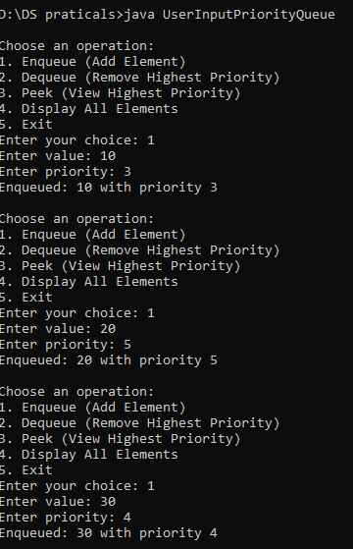
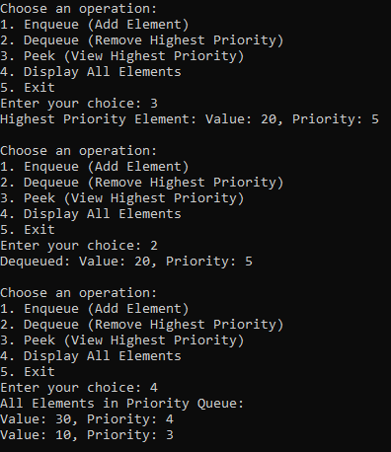

Practical 7:
Implementation of all types of linked list
Java Implementation with User Input:
1. Singly Linked List:
import java.util.Scanner;
class SinglyLinkedList {
// Node class
static class Node {
int data;
Node next;
Node(int data) {
this.data = data;
this.next = null;
}
}
private Node head;
// Insert at the end
public void insert(int data) {
Node newNode = new Node(data);
if (head == null) {
head = newNode;
} else {
Node temp = head;
while (temp.next != null) {
temp = temp.next;
}
temp.next = newNode;
}
System.out.println("Inserted: " + data);
}
// Delete the first occurrence of a value
public void delete(int data) {
if (head == null) {
System.out.println("List is empty. Cannot delete.");
return;
}
if (head.data == data) {
head = head.next;
System.out.println("Deleted: " + data);
return;
}
Node temp = head;
while (temp.next != null && temp.next.data != data) {
temp = temp.next;
}
if (temp.next == null) {
System.out.println("Element not found.");
} else {
temp.next = temp.next.next;
System.out.println("Deleted: " + data);
}
}
// Traverse and display
public void display() {
if (head == null) {
System.out.println("List is empty.");
return;
}
System.out.print("Singly Linked List: ");
Node temp = head;
while (temp != null) {
System.out.print(temp.data + "-> ");
temp = temp.next;
}
System.out.println("null");
}
public static void main(String[] args) {
SinglyLinkedList sll = new SinglyLinkedList();
Scanner scanner = new Scanner(System.in);
while (true) {
System.out.println("\n1. Insert");
System.out.println("2. Delete");
System.out.println("3. Display");
System.out.println("4. Exit");
System.out.print("Enter your choice: ");
int choice = scanner.nextInt();
switch (choice) {
case 1:
System.out.print("Enter data to insert: ");
int data = scanner.nextInt();
sll.insert(data);
break;
case 2:
System.out.print("Enter data to delete: ");
int deleteData = scanner.nextInt();
sll.delete(deleteData);
break;
case 3:
sll.display();
break;
case 4:
scanner.close();
System.out.println("Exiting...");
return;
default:
System.out.println("Invalid choice. Try again.");
}
}
}
}
Example Input and Output:
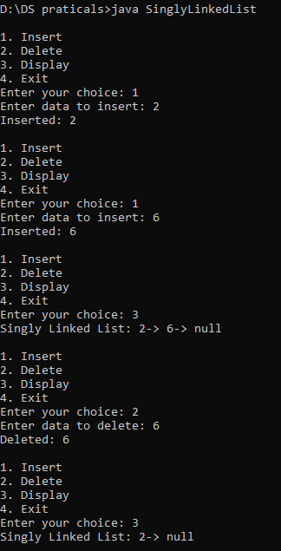

2. Doubly Linked List:
Java Implementation with User Input:
import java.util.Scanner;
class DoublyLinkedList {
static class Node {
int data;
Node prev, next;
Node(int data) {
this.data = data;
this.prev = this.next = null;
}
}
private Node head;
// Insert at the end
public void insert(int data) {
Node newNode = new Node(data);
if (head == null) {
head = newNode;
} else {
Node temp = head;
while (temp.next != null) {
temp = temp.next;
}
temp.next = newNode;
newNode.prev = temp;
}
System.out.println("Inserted: " + data);
}
// Traverse and display
public void display() {
if (head == null) {
System.out.println("List is empty.");
return;
}
System.out.print("Doubly Linked List: ");
Node temp = head;
while (temp != null) {
System.out.print(temp.data + " <-> ");
temp = temp.next;
}
System.out.println("null");
}
public static void main(String[] args) {
DoublyLinkedList dll = new DoublyLinkedList();
Scanner scanner = new Scanner(System.in);
while (true) {
System.out.println("\n1. Insert");
System.out.println("2. Display");
System.out.println("3. Exit");
System.out.print("Enter your choice: ");
int choice = scanner.nextInt();
switch (choice) {
case 1:
System.out.print("Enter data to insert: ");
int data = scanner.nextInt();
dll.insert(data);
break;
case 2:
dll.display();
break;
case 3:
scanner.close();
System.out.println("Exiting...");
return;
default:
System.out.println("Invalid choice. Try again.");
}
}
}
}

Example Input and Output:
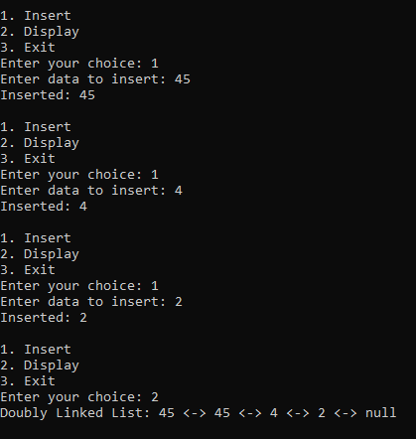

3. Circular Linked List:
Java Implementation with User Input:
import java.util.Scanner;
class CircularLinkedList {
static class Node {
int data;
Node next;
Node(int data) {
this.data = data;
this.next = null;
}
}
private Node last;
// Insert at the end
public void insert(int data) {
Node newNode = new Node(data);
if (last == null) {
last = newNode;
last.next = last;
} else {
newNode.next = last.next;
last.next = newNode;
last = newNode;
}
System.out.println("Inserted: " + data);
}
// Traverse and display
public void display() {
if (last == null) {
System.out.println("List is empty.");
return;
}
System.out.print("Circular Linked List: ");
Node temp = last.next;
do {
System.out.print(temp.data + "-> ");
temp = temp.next;
} while (temp != last.next);
System.out.println("(back to head)");
}
public static void main(String[] args) {
CircularLinkedList cll = new CircularLinkedList();
Scanner scanner = new Scanner(System.in);
while (true) {
System.out.println("\n1. Insert");
System.out.println("2. Display");
System.out.println("3. Exit");
System.out.print("Enter your choice: ");
int choice = scanner.nextInt();
switch (choice) {
case 1:
System.out.print("Enter data to insert: ");
int data = scanner.nextInt();
cll.insert(data);
break;
case 2:
cll.display();
break;
case 3:
scanner.close();
System.out.println("Exiting...");
return;
default:
System.out.println("Invalid choice. Try again.");
}
}
}
}

Example Input and Output:
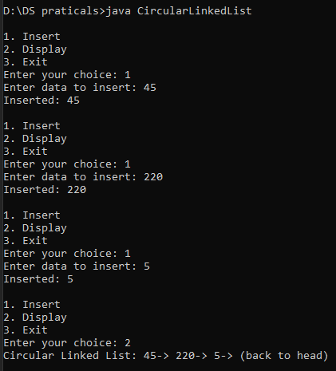

Practical 8:
Demonstrate application of linked list to implement Polynomial Addition
import java.util.Scanner;
class Node {
int coefficient, exponent;
Node next;
Node(int coefficient, int exponent) {
this.coefficient = coefficient;
this.exponent = exponent;
this.next = null;
}
}
class Polynomial {
Node head;
// Insert a term in the polynomial in sorted order by exponent
public void insertTerm(int coefficient, int exponent) {
Node newNode = new Node(coefficient, exponent);
if (head == null || head.exponent < exponent) {
newNode.next = head;
head = newNode;
} else {
Node current = head;
while (current.next != null && current.next.exponent > exponent) {
current = current.next;
}
newNode.next = current.next;
current.next = newNode;
}
}
// Display the polynomial
public void display() {
if (head == null) {
System.out.println("0");
return;
}
Node current = head;
while (current != null) {
System.out.print(current.coefficient + "x^" + current.exponent);
if (current.next != null) System.out.print(" + ");
current = current.next;
}
System.out.println();
}
// Add two polynomials
public static Polynomial add(Polynomial p1, Polynomial p2) {
Polynomial result = new Polynomial();
Node t1 = p1.head, t2 = p2.head;
while (t1 != null && t2 != null) {
if (t1.exponent == t2.exponent) {
int sumCoeff = t1.coefficient + t2.coefficient;
if (sumCoeff != 0) {
result.insertTerm(sumCoeff, t1.exponent);
}
t1 = t1.next;
t2 = t2.next;
} else if (t1.exponent > t2.exponent) {
result.insertTerm(t1.coefficient, t1.exponent);
t1 = t1.next;
} else {
result.insertTerm(t2.coefficient, t2.exponent);
t2 = t2.next;
}
}

// Add remaining terms
while (t1 != null) {
result.insertTerm(t1.coefficient, t1.exponent);
t1 = t1.next;
}
while (t2 != null) {
result.insertTerm(t2.coefficient, t2.exponent);
t2 = t2.next;
}
return result;
}
}
public class PolynomialAddition {
public static void main(String[] args) {
Scanner scanner = new Scanner(System.in);
// Create two polynomials
Polynomial p1 = new Polynomial();
Polynomial p2 = new Polynomial();
// Input first polynomial
System.out.println("Enter the number of terms for the first polynomial:");
int n1 = scanner.nextInt();
System.out.println("Enter terms (coefficient and exponent):");
for (int i = 0; i < n1; i++) {
int coeff = scanner.nextInt();
int exp = scanner.nextInt();
p1.insertTerm(coeff, exp);
}
// Input second polynomial
System.out.println("Enter the number of terms for the second polynomial:");
int n2 = scanner.nextInt();
System.out.println("Enter terms (coefficient and exponent):");
for (int i = 0; i < n2; i++) {
int coeff = scanner.nextInt();
int exp = scanner.nextInt();
p2.insertTerm(coeff, exp);
}
// Display input polynomials
System.out.println("First Polynomial:");
p1.display();
System.out.println("Second Polynomial:");
p2.display();
// Add the polynomials
Polynomial result = Polynomial.add(p1, p2);
// Display result
System.out.println("Resultant Polynomial after addition:");
result.display();
}
}

Example Input and Output:
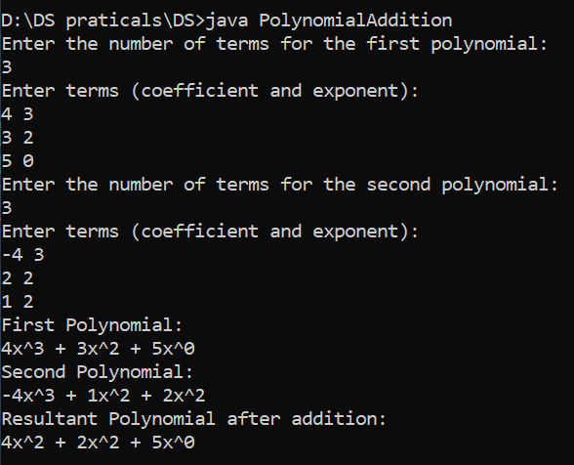

Demonstrate application of linked list to implement Sparse Matrix
import java.util.Scanner;
class Node {
int row, col, value;
Node next;
Node(int row, int col, int value) {
this.row = row;
this.col = col;
this.value = value;
this.next = null;
}
}
class SparseMatrix {
Node head;
// Add a non-zero element to the sparse matrix
public void addElement(int row, int col, int value) {
Node newNode = new Node(row, col, value);
if (head == null) {
head = newNode;
} else {
Node current = head;
while (current.next != null) {
current = current.next;
}
current.next = newNode;
}
}
// Display the sparse matrix as a list of non-zero elements
public void displayAsList() {
if (head == null) {
System.out.println("The sparse matrix is empty.");
return;
}
System.out.println("Row\tCol\tValue");
Node current = head;
while (current != null) {
System.out.println(current.row + "\t" + current.col + "\t" + current.value);
current = current.next;
}
}
// Display the full matrix for visualization
public void displayAsMatrix(int rows, int cols) {
int[][] matrix = new int[rows][cols];
Node current = head;
while (current != null) {
matrix[current.row][current.col] = current.value;
current = current.next;
}
System.out.println("Full Matrix Representation:");
for (int i = 0; i < rows; i++) {
for (int j = 0; j < cols; j++) {
System.out.print(matrix[i][j] + " ");
}
System.out.println();
}
}
}
public class SparseMatrixImplementation {
public static void main(String[] args) {
Scanner scanner = new Scanner(System.in);
// Input matrix dimensions
System.out.println("Enter the number of rows and columns of the matrix:");
int rows = scanner.nextInt();
int cols = scanner.nextInt();

// Create a sparse matrix
SparseMatrix sparseMatrix = new SparseMatrix();
// Input number of non-zero elements
System.out.println("Enter the number of non-zero elements:");
int nonZeroElements = scanner.nextInt();
// Input non-zero elements
System.out.println("Enter the row, column, and value for each non-zero element:");
for (int i = 0; i < nonZeroElements; i++) {
int row = scanner.nextInt();
int col = scanner.nextInt();
int value = scanner.nextInt();
sparseMatrix.addElement(row, col, value);
}
// Display the sparse matrix
System.out.println("\nSparse Matrix Representation (as list):");
sparseMatrix.displayAsList();
// Display the full matrix for visualization
System.out.println("\nSparse Matrix Representation (as matrix):");
sparseMatrix.displayAsMatrix(rows, cols);
}
}
Example Input and Output:
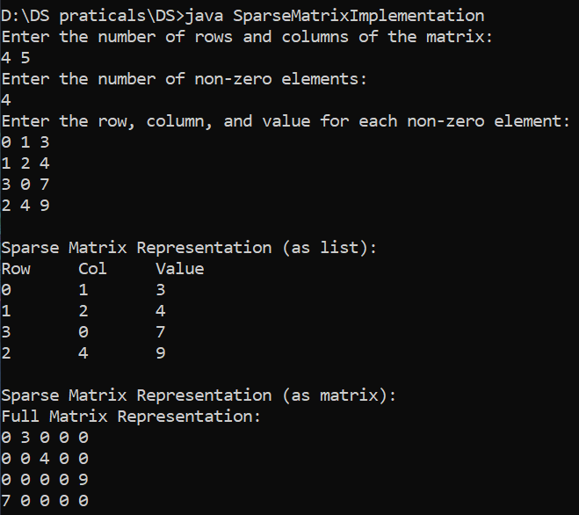

Practical 10:
10. Implementing Heap with different operations
a) To perform insertion operation
b) To create Heap using Heapify method
c) To perform Heap sort
d) To delete the value in heap
import java.util.Scanner;
// Class to implement a Max-Heap
class Heap {
private int[] heap;
private int size;
private int capacity;
// Constructor to initialize the heap
public Heap(int capacity) {
this.capacity = capacity;
heap = new int[capacity];
size = 0;
}
// Utility function to get the parent index
private int parent(int index) {
return (index - 1) / 2;
}
// Utility function to get the left child index
private int leftChild(int index) {
return 2 * index + 1;
}
// Utility function to get the right child index
private int rightChild(int index) {
return 2 * index + 2;
}
// a) Insert an element into the heap
public void insert(int value) {
if (size == capacity) {
throw new IllegalStateException("Heap is full!");
}
heap[size] = value;
size++;
heapifyUp(size - 1);
}
private void heapifyUp(int index) {
int temp = heap[index];
while (index > 0 && temp > heap[parent(index)]) {
heap[index] = heap[parent(index)];
index = parent(index);
}
heap[index] = temp;
}
// b) Create a heap using the Heapify method
public void buildHeap(int[] array) {
if (array.length > capacity) {
throw new IllegalStateException("Array exceeds heap capacity!");
}
size = array.length;
System.arraycopy(array, 0, heap, 0, size);
for (int i = (size / 2) - 1; i >= 0; i--) {
heapifyDown(i);
}
}
private void heapifyDown(int index) {
int largest = index;
int left = leftChild(index);
int right = rightChild(index);
if (left < size && heap[left] > heap[largest]) {
largest = left;
}
if (right < size && heap[right] > heap[largest]) {
largest = right;
}
if (largest != index) {
swap(index, largest);
heapifyDown(largest);
}
}
// c) Perform Heap Sort
public void heapSort() {
int originalSize = size;
for (int i = size - 1; i >= 0; i--) {
swap(0, i);
size--;
heapifyDown(0);
}
size = originalSize; // Restore original size
}
// d) Delete the root value from the heap
public int delete() {
if (size == 0) {
throw new IllegalStateException("Heap is empty!");
}
int root = heap[0];
heap[0] = heap[size - 1];
size--;
heapifyDown(0);
return root;
}
// Utility function to swap two elements in the heap
private void swap(int i, int j) {
int temp = heap[i];
heap[i] = heap[j];
heap[j] = temp;
}
// Display the heap
public void display() {
if (size == 0) {
System.out.println("Heap is empty.");
} else {
for (int i = 0; i < size; i++) {
System.out.print(heap[i] + " ");
}
System.out.println();
}
}
}
// Main class to test Heap operations
public class HeapOperations {
public static void main(String[] args) {
Scanner scanner = new Scanner(System.in);
System.out.println("Enter the capacity of the heap:");
int capacity = scanner.nextInt();
Heap heap = new Heap(capacity);
while (true) {
System.out.println("\nHeap Operations:");
System.out.println("1. Insert");
System.out.println("2. Build Heap (Heapify)");
System.out.println("3. Perform Heap Sort");
System.out.println("4. Delete Root");
System.out.println("5. Display Heap");
System.out.println("6. Exit");
System.out.print("Enter your choice: ");
int choice = scanner.nextInt();

switch (choice) {
case 1 -> {
System.out.print("Enter value to insert: ");
int value = scanner.nextInt();
try {
heap.insert(value);
System.out.println(value + " inserted.");
} catch (IllegalStateException e) {
System.out.println(e.getMessage());
}
}
case 2 -> {
System.out.print("Enter the number of elements: ");
int n = scanner.nextInt();
int[] array = new int[n];
System.out.println("Enter the elements:");
for (int i = 0; i < n; i++) {
array[i] = scanner.nextInt();
}
try {
heap.buildHeap(array);
System.out.println("Heap built using heapify.");
} catch (IllegalStateException e) {
System.out.println(e.getMessage());
}
}
case 3 -> {
System.out.println("Performing Heap Sort...");
heap.heapSort();
heap.display();
System.out.println("Heap Sort completed.");
}
case 4 -> {
try {
int deletedValue = heap.delete();
System.out.println("Deleted root value: " + deletedValue);
} catch (IllegalStateException e) {
System.out.println(e.getMessage());
}
}
case 5 -> {
System.out.println("Current Heap:");
heap.display();
}
case 6 -> {
System.out.println("Exiting...");
scanner.close();
return;
}
default -> System.out.println("Invalid choice. Please try again.");
}
}
}
}

Example Input and Output:
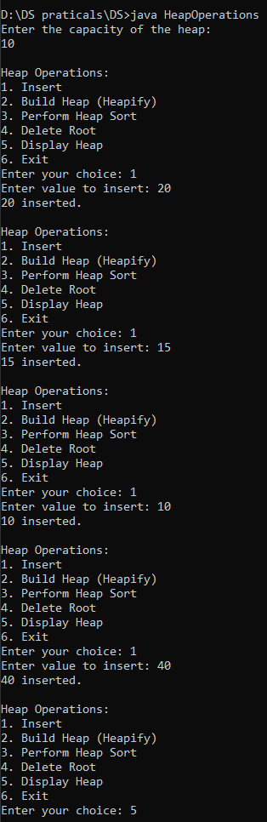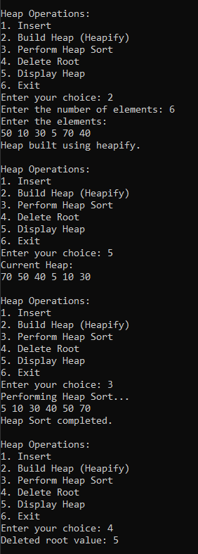

Practical 9:
9. Create and perform various operations on BST
a) Inserting node in BST
b) Deleting the node from BST
c) To find height of Tree
d) To perform Inorder
e) To perform Preorder
f) To perform Postorder
g) To find Maximum value of tree
import java.util.Scanner;
class Node {
int data;
Node left, right;
Node(int data) {
this.data = data;
left = right = null;
}
}
class BST {
Node root;
// a) Insert a node in BST
public void insert(int value) {
root = insertRec(root, value);
}
private Node insertRec(Node root, int value) {
if (root == null) {
return new Node(value);
}
if (value < root.data) {
root.left = insertRec(root.left, value);
} else if (value > root.data) {
root.right = insertRec(root.right, value);
}
return root;
}
// b) Delete a node from BST
public void delete(int value) {
root = deleteRec(root, value);
}
private Node deleteRec(Node root, int value) {
if (root == null) {
return root;
}
if (value < root.data) {
root.left = deleteRec(root.left, value);
} else if (value > root.data) {
root.right = deleteRec(root.right, value);
} else {
// Node with one or no child
if (root.left == null) return root.right;
if (root.right == null) return root.left;
// Node with two children
root.data = minValue(root.right);
root.right = deleteRec(root.right, root.data);
}
return root;
}
private int minValue(Node root) {
int minValue = root.data;
while (root.left != null) {
minValue = root.left.data;
root = root.left;
}
return minValue;
}

// c) Find height of BST
public int findHeight() {
return heightRec(root);
}
private int heightRec(Node root) {
if (root == null) return -1; // Height of an empty tree is -1
return Math.max(heightRec(root.left), heightRec(root.right)) + 1;
}
// d) Perform Inorder Traversal
public void inorder() {
System.out.print("Inorder Traversal: ");
inorderRec(root);
System.out.println();
}
private void inorderRec(Node root) {
if (root != null) {
inorderRec(root.left);
System.out.print(root.data + " ");
inorderRec(root.right);
}
}
// e) Perform Preorder Traversal
public void preorder() {
System.out.print("Preorder Traversal: ");
preorderRec(root);
System.out.println();
}
private void preorderRec(Node root) {
if (root != null) {
System.out.print(root.data + " ");
preorderRec(root.left);
preorderRec(root.right);
}
}
// f) Perform Postorder Traversal
public void postorder() {
System.out.print("Postorder Traversal: ");
postorderRec(root);
System.out.println();
}
private void postorderRec(Node root) {
if (root != null) {
postorderRec(root.left);
postorderRec(root.right);
System.out.print(root.data + " ");
}
}
// g) Find maximum value in BST
public int findMax() {
if (root == null) {
throw new IllegalStateException("Tree is empty");
}
return maxValue(root);
}
private int maxValue(Node root) {
while (root.right != null) {
root = root.right;
}
return root.data;
}
}
public class BSTOperations {
public static void main(String[] args) {
BST bst = new BST();
Scanner scanner = new Scanner(System.in);
while (true) {
System.out.println("\nBinary Search Tree Operations:");
System.out.println("1. Insert");
System.out.println("2. Delete");
System.out.println("3. Find Height");
System.out.println("4. Inorder Traversal");
System.out.println("5. Preorder Traversal");
System.out.println("6. Postorder Traversal");
System.out.println("7. Find Maximum");
System.out.println("8. Exit");
System.out.print("Enter your choice: ");
int choice = scanner.nextInt();
switch (choice) {
case 1 -> {
System.out.print("Enter value to insert: ");
int value = scanner.nextInt();
bst.insert(value);
System.out.println(value + " inserted.");
}
case 2 -> {
System.out.print("Enter value to delete: ");
int value = scanner.nextInt();
bst.delete(value);
System.out.println(value + " deleted (if present).");
}
case 3 -> System.out.println("Height of the tree: " + bst.findHeight());
case 4 -> bst.inorder();
case 5 -> bst.preorder();
case 6 -> bst.postorder();
case 7 -> {
if (bst.root == null) {
System.out.println("Tree is empty");
} else {
System.out.println("Maximum value in the tree: " + bst.findMax());
}
}
case 8 -> {
System.out.println("Exiting...");
scanner.close();
return;
}
default -> System.out.println("Invalid choice. Please try again.");
}
}
}}
Example Input and Output:
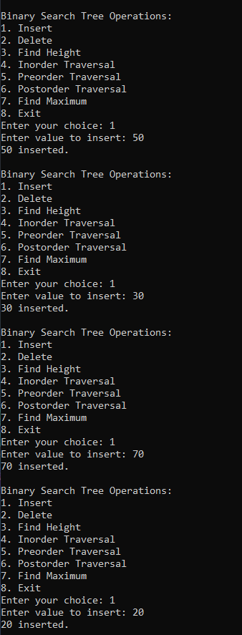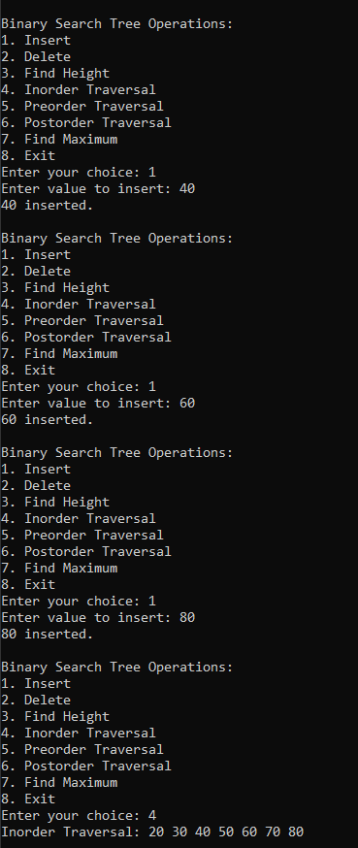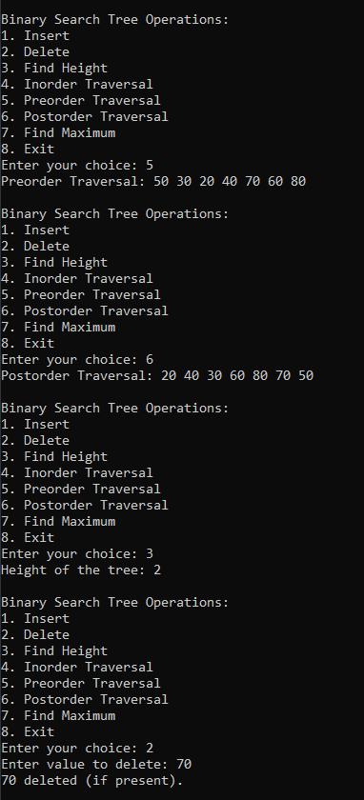

Practical 11:
Implementing Graph Using Adjacency Matrix in Java
import java.util.Scanner;
public class Graph {
private int[][] adjMatrix; // Adjacency matrix to represent the graph
private int V; // Number of vertices
// Constructor to initialize the graph with V vertices
public Graph(int V) {
this.V = V;
adjMatrix = new int[V][V]; // Initialize the adjacency matrix with all 0s
}
// Method to add an edge to the graph
public void addEdge(int u, int v) {
// Check if u and v are valid vertices
if (u < 0 || u >= V || v < 0 || v >= V) {
System.out.println("Invalid edge: (" + u + ", " + v + ")");
return;
}
// For an undirected graph, set both adjMatrix[u][v] and adjMatrix[v][u] to 1
adjMatrix[u][v] = 1;
adjMatrix[v][u] = 1; // Since it's undirected
}
// Method to print the adjacency matrix
public void printGraph() {
System.out.println("Adjacency Matrix Representation of the Graph:");
for (int i = 0; i < V; i++) {
for (int j = 0; j < V; j++) {
System.out.print(adjMatrix[i][j] + " ");
}
System.out.println();
}
}

// Main method to test the implementation
public static void main(String[] args) {
Scanner sc = new Scanner(System.in);
// Input: Number of vertices and edges
System.out.print("Enter number of vertices (V): ");
int V = sc.nextInt();
Graph graph = new Graph(V); // Create a graph with V vertices
System.out.print("Enter number of edges (E): ");
int E = sc.nextInt();
System.out.println("Enter the edges (u v) where u and v are vertices (0 to " + (V - 1) + "):");
for (int i = 0; i < E; i++) {
int u = sc.nextInt();
int v = sc.nextInt();
graph.addEdge(u, v);
}
// Print the adjacency matrix representation of the graph
graph.printGraph();
sc.close();
}
}
Example Input and Output:
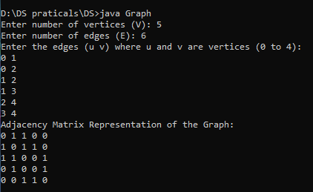
Practical 12:
Hashing with Linear Probing in Java
import java.util.Scanner;
class HashTable {
private int[] table;
private boolean[] deleted;
private int tableSize;
// Constructor to initialize the hash table
public HashTable(int size) {
tableSize = size;
table = new int[tableSize];
deleted = new boolean[tableSize];
for (int i = 0; i < tableSize; i++) {
table[i] = Integer.MIN_VALUE; // Use Integer.MIN_VALUE to indicate empty slots
deleted[i] = false; // Initially, no slots are deleted
}
}
// Hash function
private int hashFunction(int key) {
return key % tableSize;
}
// Insert a key into the hash table
public void insert(int key) {
int index = hashFunction(key);
int originalIndex = index;
while (table[index] != Integer.MIN_VALUE && table[index] != key && !deleted[index]) {
index = (index + 1) % tableSize;
if (index == originalIndex) {
System.out.println("Hash table is full! Cannot insert key: " + key);
return;
}
}
table[index] = key;
deleted[index] = false; // Mark as not deleted
System.out.println("Inserted key " + key + " at index " + index);
}
// Search for a key in the hash table
public boolean search(int key) {
int index = hashFunction(key);
int originalIndex = index;
while (table[index] != Integer.MIN_VALUE) {
if (table[index] == key && !deleted[index]) {
return true;
}
index = (index + 1) % tableSize;
if (index == originalIndex) {
break;
}
}
return false;
}
// Delete a key from the hash table
public void delete(int key) {
int index = hashFunction(key);
int originalIndex = index;
while (table[index] != Integer.MIN_VALUE) {
if (table[index] == key && !deleted[index]) {
deleted[index] = true; // Mark as deleted
System.out.println("Deleted key " + key + " from index " + index);
return;
}
index = (index + 1) % tableSize;
if (index == originalIndex) {
break;
}
}
System.out.println("Key " + key + " not found!");
}
// Display the hash table
public void display() {
System.out.println("\nHash Table:");
for (int i = 0; i < tableSize; i++) {
if (table[i] != Integer.MIN_VALUE && !deleted[i]) {
System.out.println("Index " + i + ": " + table[i]);
} else {
System.out.println("Index " + i + ": Empty");
}
}
}
}
public class HashingWithLinearProbing {
public static void main(String[] args) {
Scanner scanner = new Scanner(System.in);
System.out.print("Enter the size of the hash table: ");
int size = scanner.nextInt();
HashTable hashTable = new HashTable(size);
while (true) {
System.out.println("\nHash Table Operations:");
System.out.println("1. Insert");
System.out.println("2. Search");
System.out.println("3. Delete");
System.out.println("4. Display");
System.out.println("5. Exit");
System.out.print("Enter your choice: ");
int choice = scanner.nextInt();
switch (choice) {
case 1: // Insert
System.out.print("Enter the key to insert: ");
int keyToInsert = scanner.nextInt();
hashTable.insert(keyToInsert);
break;
case 2: // Search
System.out.print("Enter the key to search: ");
int keyToSearch = scanner.nextInt();
if (hashTable.search(keyToSearch)) {
System.out.println("Key " + keyToSearch + " is present in the hash table.");
} else {
System.out.println("Key " + keyToSearch + " is not found in the hash table.");
}
break;
case 3: // Delete
System.out.print("Enter the key to delete: ");
int keyToDelete = scanner.nextInt();
hashTable.delete(keyToDelete);
break;
case 4: // Display
hashTable.display();
break;
case 5: // Exit
System.out.println("Exiting...");
scanner.close();
System.exit(0);
break;
default:
System.out.println("Invalid choice! Please try again.");
}
}
}
}
Example Input and Output:
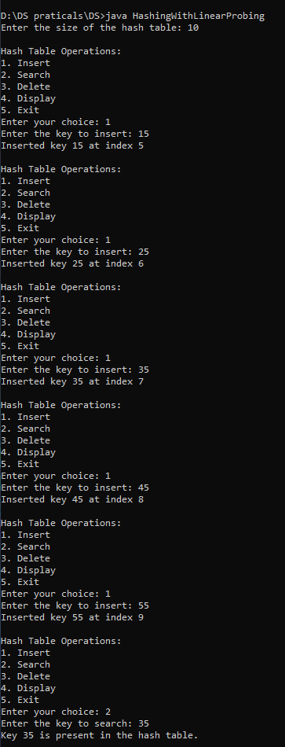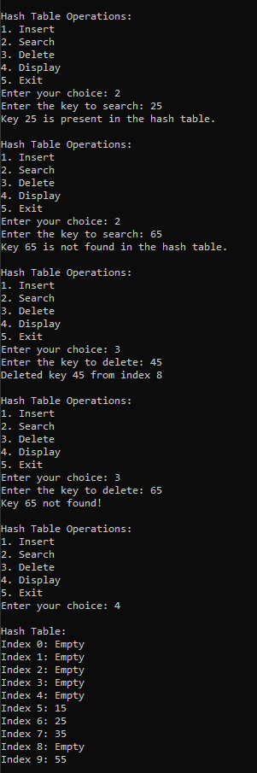

Practical 14:
Implementation of Graph traversal. (DFS and BFS)
import java.util.*;
public class GraphTraversal {
private int V; // Number of vertices
private int[][] adjMatrix; // Adjacency matrix
// Constructor
public GraphTraversal(int V) {
this.V = V;
adjMatrix = new int[V][V]; // Initialize the adjacency matrix
}
// Method to add an edge in an undirected graph
public void addEdge(int u, int v) {
adjMatrix[u][v] = 1;
adjMatrix[v][u] = 1; // Since it's undirected, mirror the edge
}
// BFS Traversal
public void bfs(int start) {
boolean[] visited = new boolean[V];
Queue<Integer> queue = new LinkedList<>();
// Start from the 'start' vertex
visited[start] = true;
queue.offer(start);
System.out.print("BFS Traversal: ");
while (!queue.isEmpty()) {
int node = queue.poll();
System.out.print((char)(node + 65) + " "); // Convert index to char (A, B, C, ...)
// Visit all neighbors of the current node
for (int i = 0; i < V; i++) {
if (adjMatrix[node][i] == 1 && !visited[i]) {
visited[i] = true;
queue.offer(i);
}
}
}
System.out.println();
}
// DFS Traversal
public void dfs(int start) {
boolean[] visited = new boolean[V];
System.out.print("DFS Traversal: ");
dfsUtil(start, visited);
System.out.println();
}
// Utility function for DFS (recursive)
private void dfsUtil(int node, boolean[] visited) {
visited[node] = true;
System.out.print((char)(node + 65) + " "); // Convert index to char (A, B, C, ...)
// Visit all neighbors of the current node
for (int i = 0; i < V; i++) {
if (adjMatrix[node][i] == 1 && !visited[i]) {
dfsUtil(i, visited);
}
}
}
public static void main(String[] args) {
Scanner sc = new Scanner(System.in);
// Get number of vertices and edges from the user
System.out.print("Enter the number of vertices: ");
int V = sc.nextInt();
GraphTraversal graph = new GraphTraversal(V); // Create a graph with V ertices
System.out.print("Enter the number of edges: ");
int E = sc.nextInt();
// Get edges from the user
System.out.println("Enter the edges (u v) where u and v are vertices (0 to " + (V-1) + "):");
for (int i = 0; i < E; i++) {
int u = sc.nextInt();
int v = sc.nextInt();
if (u >= 0 && u < V && v >= 0 && v < V) {
graph.addEdge(u, v);
} else {
System.out.println("Invalid edge input: vertices out of range (0 to " + (V-1) + ").");
i--; // Decrement to retry the input
}
}
// Get the start vertex for BFS and DFS
System.out.print("Enter the start vertex for BFS and DFS (0 to " + (V-1) + "): ");
int start = sc.nextInt();
graph.bfs(start);
graph.dfs(start);
sc.close();
}
}
Example Input and Output:
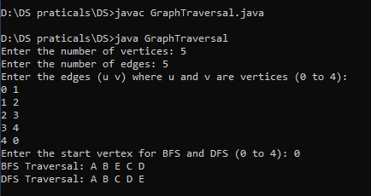

Practical 13:
Kruskal’s Algorithm in Java
import java.util.*;
public class KruskalMST {
// Union-Find data structure
static class UnionFind {
int[] parent;
int[] rank;
UnionFind(int n) {
parent = new int[n];
rank = new int[n];
for (int i = 0; i < n; i++) {
parent[i] = i;
rank[i] = 0;
}
}
int find(int x) {
if (parent[x] != x) {
parent[x] = find(parent[x]);
}
return parent[x];
}
void union(int x, int y) {
int rootX = find(x);
int rootY = find(y);
if (rootX != rootY) {
// Union by rank
if (rank[rootX] > rank[rootY]) {
parent[rootY] = rootX;
} else if (rank[rootX] < rank[rootY]) {
parent[rootX] = rootY;
} else {
parent[rootY] = rootX;
rank[rootX]++;
}
}
}
}
static class Edge {
int u, v, weight;
Edge(int u, int v, int weight) {
this.u = u;
this.v = v;
this.weight = weight;
}
}
// Kruskal's algorithm to find MST
public static void kruskalMST(int V, List<Edge> edges) {
UnionFind uf = new UnionFind(V);
// Sort edges by weight
edges.sort(Comparator.comparingInt(e -> e.weight));
List<Edge> mst = new ArrayList<>();
int mstWeight = 0;
// Process each edge in sorted order
for (Edge edge : edges) {
int u = edge.u;
int v = edge.v;
int weight = edge.weight;
// If adding this edge doesn't form a cycle, include it in the MST
if (uf.find(u) != uf.find(v)) {
uf.union(u, v);
mst.add(edge);
mstWeight += weight;
}
}
// Print the MST
System.out.println("Edges in MST:");
for (Edge edge : mst) {
System.out.println((char)(edge.u + 65) + " - " + (char)(edge.v + 65) + " with weight " + edge.weight);
}
System.out.println("Total weight of MST: " + mstWeight);
}
public static void main(String[] args) {
Scanner sc = new Scanner(System.in);
System.out.print("Enter number of vertices (V): ");
int V = sc.nextInt();
System.out.print("Enter number of edges (E): ");
int E = sc.nextInt();
List<Edge> edges = new ArrayList<>();
System.out.println("Enter edges (u v weight):");
for (int i = 0; i < E; i++) {
int u = sc.nextInt();
int v = sc.nextInt();
int weight = sc.nextInt();
if (u >= 0 && u < V && v >= 0 && v < V) {
edges.add(new Edge(u, v, weight));
} else {
System.out.println("Invalid edge input: vertices out of range (0 to " + (V - 1) + ").");
i--; // Decrement to retry the input
}
}
kruskalMST(V, edges);
sc.close();
}
}

Example Input and Output:
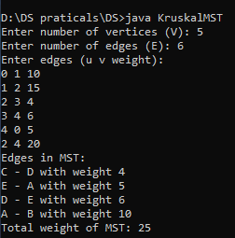

Prim’s Algorithm in Java:
import java.util.*;
public class PrimMST {
// Prim's algorithm to find MST
public static void primMST(int V, List<List<int[]>> adj) {
boolean[] visited = new boolean[V];
PriorityQueue<int[]> pq = new PriorityQueue<>(Comparator.comparingInt(a -> a[1])); // Min-heap based on weight
// Start from the first vertex (vertex 0)
pq.add(new int[]{0, 0}); // {vertex, weight}
int mstWeight = 0;
List<String> mstEdges = new ArrayList<>();
while (!pq.isEmpty()) {
int[] edge = pq.poll();
int u = edge[0];
int weight = edge[1];
// If this vertex has already been visited, skip it
if (visited[u]) continue;
visited[u] = true;
mstWeight += weight;
// Add the edge to MST (skip the starting vertex 0)
if (weight > 0) {
mstEdges.add((char)(u + 65) + " - " + (char)(edge[0] + 65) + " with weight " + weight);
}
// Add all the neighbors to the priority queue
for (int[] neighbor : adj.get(u)) {
int v = neighbor[0];
int w = neighbor[1];
if (!visited[v]) {
pq.add(new int[]{v, w});
}
}
}
// Print the MST
System.out.println("Edges in MST:");
for (String edge : mstEdges) {
System.out.println(edge);
}
System.out.println("Total weight of MST: " + mstWeight);
}
public static void main(String[] args) {
Scanner sc = new Scanner(System.in);
System.out.print("Enter number of vertices (V): ");
int V = sc.nextInt();
System.out.print("Enter number of edges (E): ");
int E = sc.nextInt();
List<List<int[]>> adj = new ArrayList<>();
for (int i = 0; i < V; i++) {
adj.add(new ArrayList<>());
}
System.out.println("Enter edges (u v weight):");
for (int i = 0; i < E; i++) {
int u = sc.nextInt();
int v = sc.nextInt();
int weight = sc.nextInt();
if (u >= 0 && u < V && v >= 0 && v < V) {
adj.get(u).add(new int[]{v, weight});
adj.get(v).add(new int[]{u, weight});
} else {
System.out.println("Invalid edge input: vertices out of range (0 to " + (V - 1) + ").");
i--; // Decrement to retry the input
}
}
primMST(V, adj);
sc.close();
}
}
Example Input and Output:
